Task 1:

1. Install Jupyter notebook and run the first program and share the screenshot of the output.

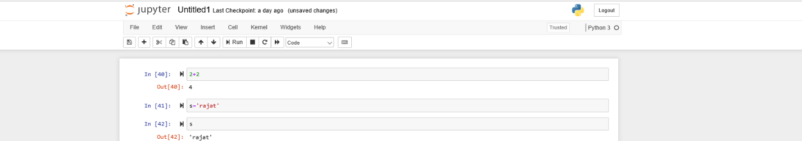

2. Write a program which will find all such numbers which are divisible by 7 but are not a multiple of 5, between 2000 and 3200 (both included). The numbers obtained should be printed in a comma-separated sequence on a single line.

|  |
| --- |
| a = 2000  b = 3200  s=[]  while a <=b:  c = a%7  d = a%5  if c == 0 and d != 0:  s.append(a+0)  a=a+1  if a == 3200:  print(s) |

Note: I found in online using Join to get he numbers in one row. I do not know the use of Join, so did not use.

3. Write a Python program to accept the user's first and last name and then getting them printed in the the reverse order with a space between first name and last name.

|  |
| --- |
| a=input()  r=[]  r=a[::-1]  print(r) |

4. Write a Python program to find the volume of a sphere with diameter 12 cm.

Formula: V=4/3 * π * r 3

|  |
| --- |
| r =12  v=0  pi=3.14  v=4/3 * 3.14 * r  print("Volumne:", v) |

Task 2:

1.

Write a program which accepts a sequence of comma-separated numbers from console and generate a list

|  |
| --- |
| l = input("Input some comma seprated numbers : ")  print('List : ',l) |

2.

Create the below pattern using nested for loop in Python.

*

* *

* * *

* * * *

* * * * *

* * * *

* * *

* *

*

|  |
| --- |
| s='*'  a=1  while a<=5:  for i in s:  print(s*a)  a = a + 1  while a>=1:  for i in s:  print(s*a)  a = a -1 |

3. Write a Python program to reverse a word after accepting the input from the user.

|  |
| --- |
| a=input()  r=[]  r=a[::-1]  print(r) |

4. Write a Python Program to print the given string in the format specified in the ​sample output.

WE, THE PEOPLE OF INDIA, having solemnly resolved to constitute India into a SOVEREIGN, SOCIALIST, SECULAR, DEMOCRATIC REPUBLIC and to secure to all its citizens

Sample Output:

WE, THE PEOPLE OF INDIA, having solemnly resolved to constitute India into a SOVEREIGN, ! SOCIALIST, SECULAR, DEMOCRATIC REPUBLIC and to secure to all its citizens

NOTE:​ ​The​ ​solution​ ​shared​ ​through​ ​Github​ ​should​ ​contain​ ​the​ ​source code​ ​used​ ​ and​ ​the​ ​screenshot​ ​of​ ​the​ ​output.

print("WE, THE PEOPLE OF INDIA, \n\t having solemnly resolved to constitute India into a SOVEREIGN!, \n \t \t SOCIALIST, SECULAR, DEMOCRATIC REPUBLIC,\n\t\t and to secure to all its citizens")

